Assignment:- 3
Verification of Logic Gates and Boolean Algebra
The following are the logic gates and their outputs-
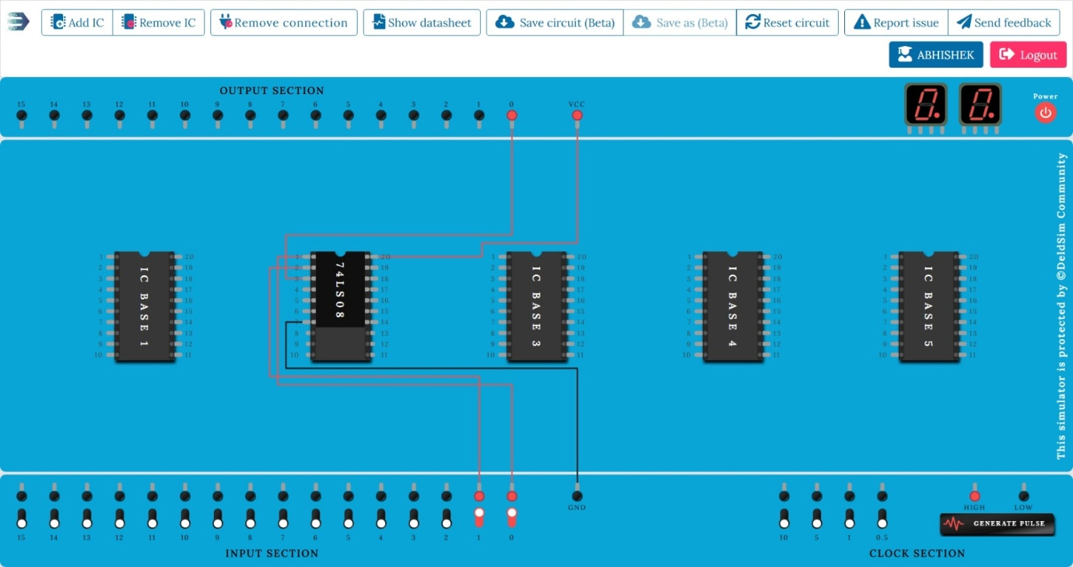
AND gate:-

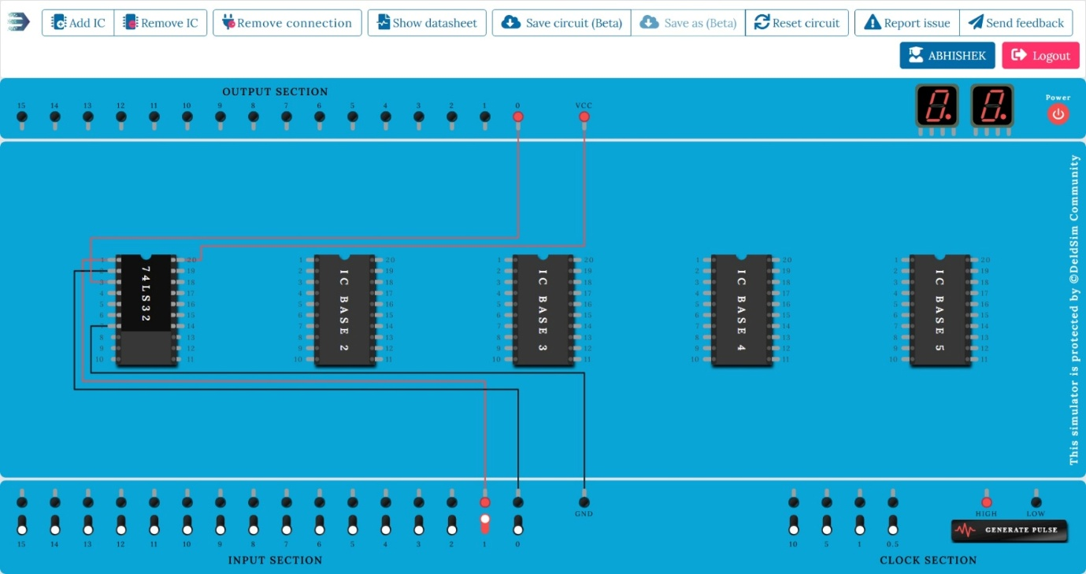
OR gate:-

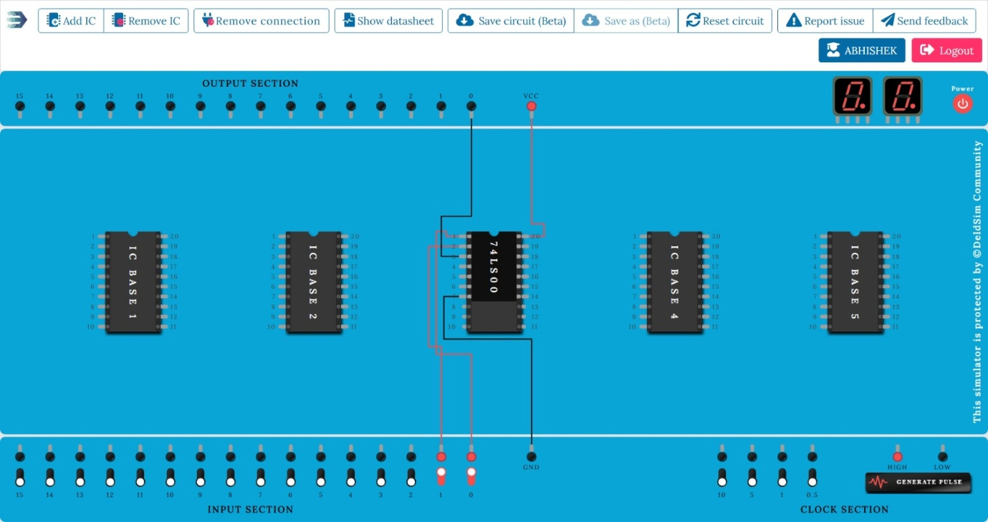
NAND gate:-

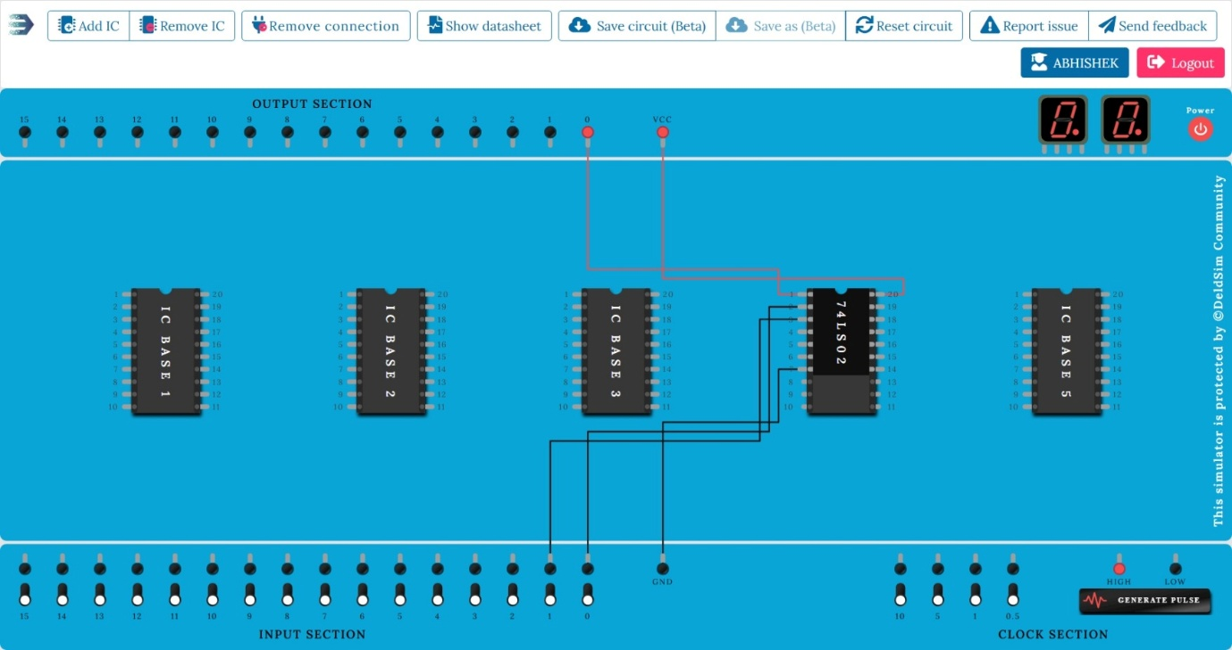
NOR gate:-

Laws for Boolean algebra:-
(a) Associative Law:-
- States that the grouping of variables does not affect the result.
- For AND (•):
(A•B)•C=A•(B•C)(A•B)•C=A•(B•C)(A•B)•C=A•(B•C)
- For OR (+):
(A+B)+C=A+(B+C)(A+B)+C=A+(B+\C)(A+B)+C=
A+(B+C)
(b) Distributive Law:-
- States that multiplication can be distributed over addition and vice versa.
- A•(B+C)=(A•B)+(A•C)A•(B+C)=(A•B)+(A•C)A•(B+C)=(A•B)+(A•C)
- A+(B•C)=(A+B)•(A+C)A+(B•C)=(A+B)•(A+C)A+
(B•C)=(A+B)•(A+C)
(c) Absorption Law:-
- Simplifies expressions by "absorbing" terms.
- A+(A•B)=AA + (A • B) = AA+(A•B)=A
- A•(A+B)=AA • (A + B) = AA•(A+B)=A

De Morgan’s Theorem:-
Used to simplify Boolean expressions involving NOT operations.
- (A•B)’=A’+B’(A • B)’ = A’ + B’(A•B)’=A’+B’
(Complement of AND = OR of complements)
- (A+B)’=A’•B’(A + B)’ = A’ • B’(A+B)’=A’•B’
(Complement of OR = AND of complements)

Principle of Duality:-
- Every Boolean equation remains valid if we interchange + and • and replace 0 with 1 and 1 with 0.
- Example:
  - Original: A+0=AA + 0 = AA+0=A
  - Dual: A•1=AA • 1 = AA•1=A

Minterm and SOP (Sum of Products):-
Minterm:
- A product (AND) term where each variable appears once (either complemented or uncomplemented).
- Example for 2 variables:
  - M0 = A’B’
  - M1 = A’B
  - M2 = AB’
  - M3 = AB
Sum of Products (SOP):
- Expression is the sum (OR) of selected minterms.
A | B | Minterm (Product) | Decimal Index
0 | 0 | A’B’ | m0
0 | 1 | A’B | m1
1 | 0 | AB’ | m2
1 | 1 | AB | m3

- Example SOP:
F(A,B)=m1+m3=A’B+ABF(A,B)=m1+m3 = A’B + ABF(A,B)=m1+m3=A’B+AB

Maxterm and POS (Product of Sums):-
Maxterm:
- A sum (OR) term where each variable appears once (either complemented or uncomplemented).
- Example for 2 variables:
  - M0 = A + B
  - M1 = A + B’
  - M2 = A’ + B
  - M3 = A’ + B’
Product of Sums (POS):
- Expression is the product (AND) of selected maxterms.
A | B | Maxterm (Sum) | Decimal Index
0 | 0 | A + B | M0
0 | 1 | A + B’ | M1
1 | 0 | A’ + B | M2
1 | 1 | A’ + B’ | M3

- Example POS:
F(A,B)=M0•M2=(A+B)(A’+B)F(A,B) = M0 • M2 = (A+B)(A’+B)F(A,B)=M0•M2=(A+B)(A’+B)

